**Sampling design for Ecological Assessment of Bumphead Parrotfish and Humphead Wrasse in Palau**

Alan Friedlander

Fisheries Ecology Research Lab

University of Hawaii, Honolulu, Hawaii

28 April 28, 2013

Objectives: Determine the optimal sample size for sampling bumphead and humphead wrasse around Palau and allocate these samples among the appropriate habitats and proportional to those habitats.

Methods: Twenty minute snorkel swims were conducted while towing a GPS in order to estimate the abundance of bumphead parrotfish and humphead wrasse in Palau.

Results: A total of 27 surveys were conducted around Palau with bumphead parrotfishes being observed on 63% of these surveys with an average number per survey of 8.8 (± 19.8 sd). Humphead wrasse were observed on 67% of the surveys but the average number observed was only 1.1 (± 19.9) with a coefficient of variation nearly double that of bumphead parrotfishes (Table 1).

Using sample size optimization based on the coefficient of variation, we calculated that 25 samples would be necessary to determine a 20% change in abundance for bumphead parrotfishes and 93 samples would be required to determine a 20% change in humphead wrasse (Table 2, Figure 1). Only 12 surveys would be required to detect a 30% change for bumphead parrotfishes and 41 surveys would be needed to detect a 30% for humphead wrasse.

Table 1. Summary statistics for 20 minute snorkel surveys conducted around Palau.

|  |  |  |  |
| --- | --- | --- | --- |
| Statistics | Bumphead parrotfish | Humphead wrasse | Total |
| Total number | 239 | 31 | 270 |
| Average number per survey | 8.85 | 1.15 | 10.00 |
| Standard deviation | 19.77 | 1.17 | 19.86 |
| Coefficient of variantion | 0.50 | 0.94 | 1.99 |
| Frequency of occurrence | 63.0% | 66.7% | 81.5% |

Table 2. Number of surveys needed to determine the corresponding level of change in abundance for bumphead parrotfish and humphead wrasse in Palau.

|  |  |  |
| --- | --- | --- |
| % change | Bumphead parrotfish | Napoleon wrasse |
| 10% | 106.26 | 372.44 |
| 20% | 26.57 | 93.11 |
| 30% | 11.81 | 41.38 |
| 40% | 6.64 | 23.28 |
| 50% | 4.25 | 14.90 |
| 60% | 2.95 | 10.35 |
| 70% | 2.17 | 7.60 |
| 80% | 1.66 | 5.82 |



Figure 1. Number of surveys needed to determine the corresponding level of change in abundance for bumphead parrotfish and humphead wrasse in Palau.

Sample design: A total of 60 samples were allocated between 2 major habitat types: forereef and lagoon. Sample locations in the lagoon habitat were confined to the aggregated patch reef habitat and backreef. Samples were allocated proportional to the amount of habitat with 67% of the samples allocated in the lagoon habitat and 33% on the forereef (Table 3, Figure 2).

Table 3. Amount of habitat for the two major habitat types for the proposed sampling design.

|  |  |  |  |
| --- | --- | --- | --- |
| ZONE | Area km2 | % | Number of samples |
| Lagoon | 290.08 | 67.29% | 40 |
| Forereef | 141.02 | 32.71% | 20 |
| Total | 431.10 |  |  |

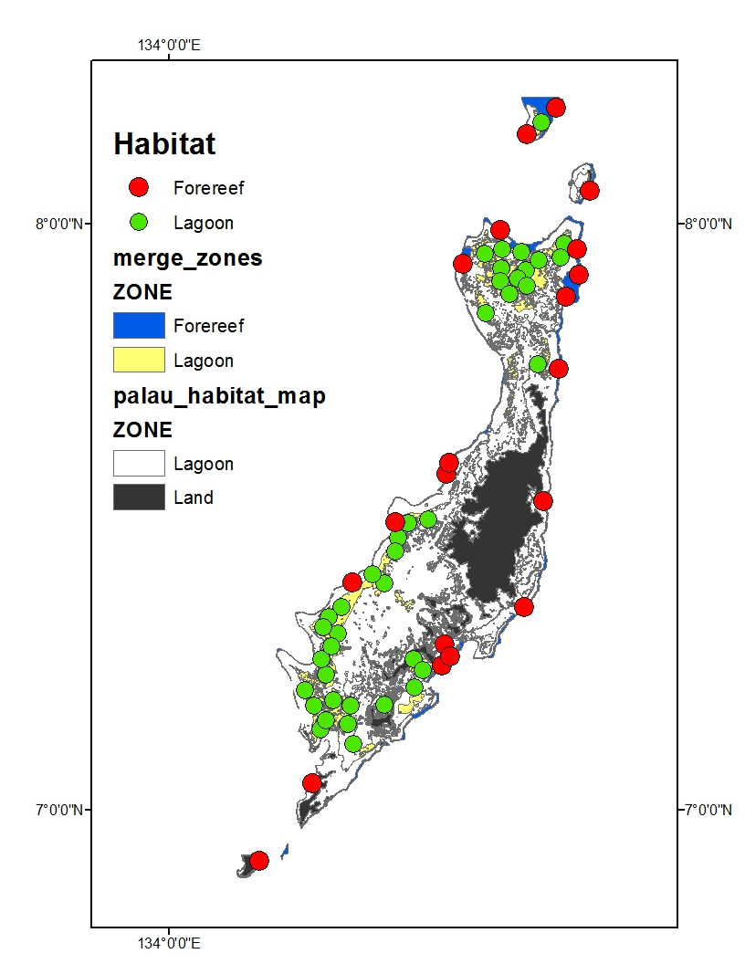

Figure 2. Sampling locations around Palau

Appendix:Sampling locations

|  |  |  |  |
| --- | --- | --- | --- |
| Id | ZONE | POINT_X | POINT_Y |
| 1 | Lagoon | 134.569 | 7.957 |
| 2 | Lagoon | 134.418 | 7.258 |
| 3 | Lagoon | 134.294 | 7.346 |
| 4 | Lagoon | 134.610 | 7.922 |
| 5 | Lagoon | 134.268 | 7.230 |
| 6 | Lagoon | 134.567 | 7.925 |
| 7 | Lagoon | 134.632 | 7.939 |
| 8 | Lagoon | 134.367 | 7.386 |
| 9 | Lagoon | 134.636 | 8.173 |
| 10 | Lagoon | 134.391 | 7.464 |
| 11 | Lagoon | 134.595 | 7.908 |
| 12 | Lagoon | 134.611 | 7.895 |
| 13 | Lagoon | 134.259 | 7.137 |
| 14 | Lagoon | 134.260 | 7.257 |
| 15 | Lagoon | 134.305 | 7.147 |
| 16 | Lagoon | 134.539 | 7.949 |
| 17 | Lagoon | 134.674 | 7.966 |
| 18 | Lagoon | 134.420 | 7.208 |
| 19 | Lagoon | 134.233 | 7.204 |
| 20 | Lagoon | 134.442 | 7.496 |
| 21 | Lagoon | 134.310 | 7.178 |
| 22 | Lagoon | 134.540 | 7.848 |
| 23 | Lagoon | 134.433 | 7.238 |
| 24 | Lagoon | 134.367 | 7.180 |
| 25 | Lagoon | 134.247 | 7.178 |
| 26 | Lagoon | 134.268 | 7.153 |
| 27 | Lagoon | 134.565 | 7.902 |
| 28 | Lagoon | 134.347 | 7.402 |
| 29 | Lagoon | 134.272 | 7.329 |
| 30 | Lagoon | 134.408 | 7.490 |
| 31 | Lagoon | 134.602 | 7.953 |
| 32 | Lagoon | 134.315 | 7.113 |
| 33 | Lagoon | 134.288 | 7.300 |
| 34 | Lagoon | 134.629 | 7.760 |
| 35 | Lagoon | 134.263 | 7.311 |
| 36 | Lagoon | 134.386 | 7.441 |
| 37 | Lagoon | 134.281 | 7.187 |
| 38 | Lagoon | 134.668 | 7.943 |
| 39 | Lagoon | 134.582 | 7.881 |
| Id | ZONE | POINT_X | POINT_Y |
| 41 | Forereef | 134.470 | 7.282 |
| 42 | Forereef | 134.466 | 7.247 |
| 43 | Forereef | 134.718 | 8.057 |
| 44 | Forereef | 134.565 | 7.990 |
| 45 | Forereef | 134.501 | 7.933 |
| 46 | Forereef | 134.386 | 7.491 |
| 47 | Forereef | 134.606 | 7.346 |
| 48 | Forereef | 134.473 | 7.573 |
| 49 | Forereef | 134.154 | 6.913 |
| 50 | Forereef | 134.666 | 7.753 |
| 51 | Forereef | 134.481 | 7.262 |
| 52 | Forereef | 134.245 | 7.045 |
| 53 | Forereef | 134.696 | 7.957 |
| 54 | Forereef | 134.677 | 7.876 |
| 55 | Forereef | 134.639 | 7.527 |
| 56 | Forereef | 134.479 | 7.592 |
| 57 | Forereef | 134.611 | 8.153 |
| 58 | Forereef | 134.699 | 7.913 |
| 59 | Forereef | 134.660 | 8.199 |
| 60 | Forereef | 134.313 | 7.388 |