The generous grant from the Walker Foundation supported The Nature Conservancy’s efforts to establish the Ayampe water fund in Ecuador. Once established, the fund will provide ongoing, sustainable funding for the conservation of 300,000 acres in the Ayampe watershed, safeguarding water sources for 20,000 people in the municipality of Puerto Lopez while protecting the last remnants of tropical dry forest.
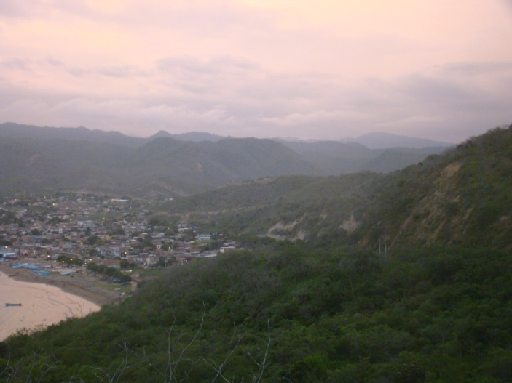 | 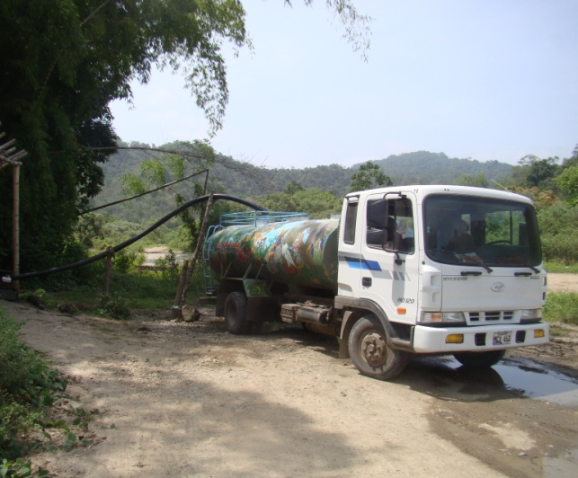
Puerto Lopez © Jaime Camacho | Water truck filling up at the Ayampe  River for water deliveries in Puerto Lopez.
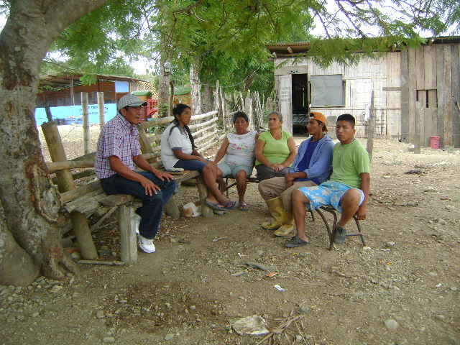 | 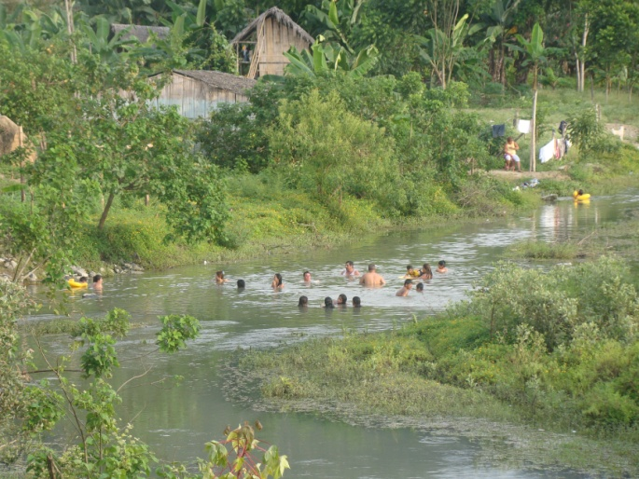
Edison Quimis, Conservancy consultant talks with Guale residents about the community’s conservation workplan. © Rolando Garcia. | Ayampe River / communities. © Jaime Camacho
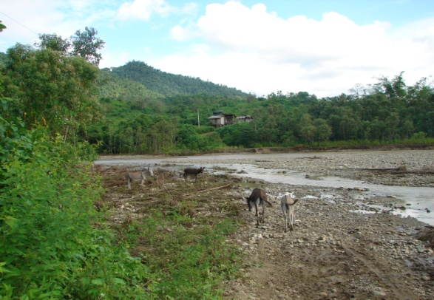  Donkeys on the river bend. © Jaime Camacho | 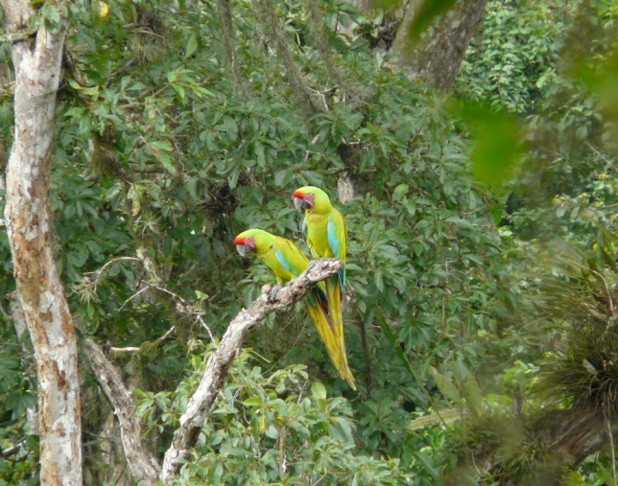  Great Green Macaws © Sanjayan

