**Project update June 2013**

**Project: Ecological and Economic Assessment of Bumphead Parrotfish and Humphead Wrasse in Palau to develop market-based and culturally appropriate management options**

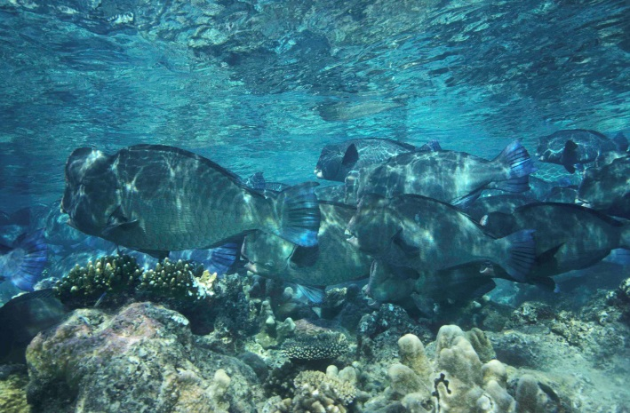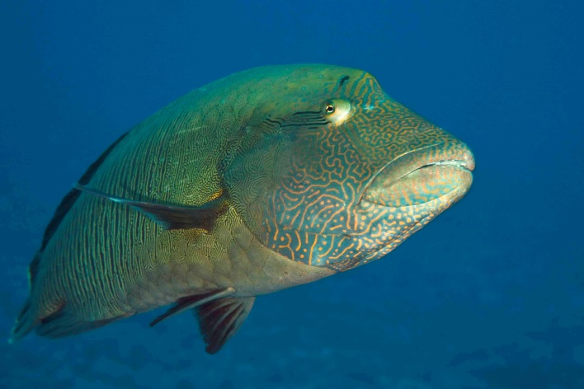

Alan Friedlander1, Haruko Koike1, Geory Mereb2, Lawrence Samor3 Kevin Polloi2

1Fisheries Ecology Research Lab, University of Hawaii

2 Palau International Coral Reef Center

3 Division of Marine Resources, Government of Palau

**Statement of Purpose:**

To undertake a project to determine ecological, economic and subsistence values for *kemedukl* (green humphead parrotfish, *Bolbometapon muricatum*), and *maml* (humphead wrasse, *Cheilinus undulates* in the Republic of Palau to develop market-based and other options for effective management.

The Fisheries Ecology Research Lab at the University of Hawaii, in conjunction with the Palau International Coral Reef Center (PICRC), The Palau Department of Marine Resources, and the Nature Conservancy conducted surveys of *kemedukl* and *maml* in the waters around Palau from 15 to 24 June 2013.

**Pilot study**: A pilot study was conducted in order to determine the optimal sample size for sampling bumphead and humphead wrasse around Palau and allocate these samples among the appropriate habitats and proportional to those habitats. Twenty minute snorkel swims were conducted in order to estimate the abundance of bumphead parrotfish and humphead wrasse in Palau. A total of 27 surveys were conducted with bumphead parrotfish being observed on 63% of these surveys with an average number per survey of 8.8 (± 19.8 sd). Humphead wrasse were observed on 67% of the surveys but the average number observed was only 1.1 (± 1.2) with a coefficient of variation nearly double that of bumphead parrotfishes (Table 1).

We calculated that 25 samples would be necessary to determine a 20% change in abundance for bumphead parrotfishes and 93 samples would be required to determine a 20% change in humphead wrasse (Table 2, Figure 1). Only 12 surveys would be required to detect a 30% change for bumphead parrotfishes and 41 surveys would be needed to detect a 30% for humphead wrasse.

**Table 1. Summary statistics for 20 minute snorkel surveys conducted around Palau.**

|  |  |  |  |
| --- | --- | --- | --- |
| Statistics | Bumphead parrotfish | Humphead wrasse | Total |
| Total number | 239 | 31 | 270 |
| Average number per survey | 8.85 | 1.15 | 10.00 |
| Standard deviation | 19.77 | 1.17 | 19.86 |
| Coefficient of variation | 0.50 | 0.94 | 1.99 |
| Frequency of occurrence | 63.0% | 66.7% | 81.5% |

**Table 2. Number of surveys needed to determine the corresponding level of change in abundance for bumphead parrotfish and humphead wrasse in Palau.**

|  |  |  |
| --- | --- | --- |
| % change | Bumphead parrotfish | Napoleon wrasse |
| 10% | 106.26 | 372.44 |
| 20% | 26.57 | 93.11 |
| 30% | 11.81 | 41.38 |
| 40% | 6.64 | 23.28 |
| 50% | 4.25 | 14.90 |
| 60% | 2.95 | 10.35 |
| 70% | 2.17 | 7.60 |
| 80% | 1.66 | 5.82 |



**Figure 1. Number of surveys needed to determine the corresponding level of change in abundance for bumphead parrotfish and humphead wrasse in Palau.**

**Sampling for stock assessment**: Based on data from the pilot study, we designed a statistically robust sampling design to assess the density and biomass of green humphead parrotfish and humphead wrasse around the main islands of Palau. Time swims were conducted to assess abundances of *kemedukl* and *maml* by towing a GPS and estimating the number and size of these two species within a 20 m width. Sampling was stratified by habitats with the four habitat types surveyed included forereef, patch reef, fringing reef, backreef.

Between 15 to 24 June 2013, 85 surveys were conducted around Palau. After including the surveys from the pilot study, 105 surveys were completed among all habitats combined (Fig. 2). The forereef habitat accounted for 56% of all the samples, followed by patch reefs (25%), fringing reefs (12%), and backreef (<1%, Table 3). The average length of each survey was 659 m with the longest survey covering 1.1 km and the shortest being 372 m (Table 4).

**Table 3. Number of surveys by habitat type.**

|  |  |
| --- | --- |
| Habitat | N |
| Backreef | 7 |
| Forereef | 59 |
| Fringing | 13 |
| Patch reef | 26 |
| Total | 105 |

**Table 4. Summary statistics for survey tracks.**

|  |  |
| --- | --- |
| Summary stats | Distance (m) |
| mean | 659.34 |
| ± sd | 149.08 |
| Max | 1154.29 |
| min | 372.57 |

**Densities of *kemedukl* and *maml***: The average number of kemedukl per transect was 4.5 (± 11.0). The average number of maml per transect was 1.5 (± 1.7). Densities of kemedukl were highest on the forereef and lowest in the backreef habitat (Table 5). Densities of maml were also highest on the forereef, along with the fringing reef habitat; although overall densities did not differ substantially among habitat types.

Kemedukl were more common along the windward coast and to the north, while maml were more common in the middle and southern portions of Palau (Fig. 3). Most large Kemedukl were found on the forereef with juveniles and sub-adults more common in fringing and patch reef habitats (Table 6). A wide size range of Maml was distributed within the forereef habitat and juveniles and sub-adults were found in all habitat types.

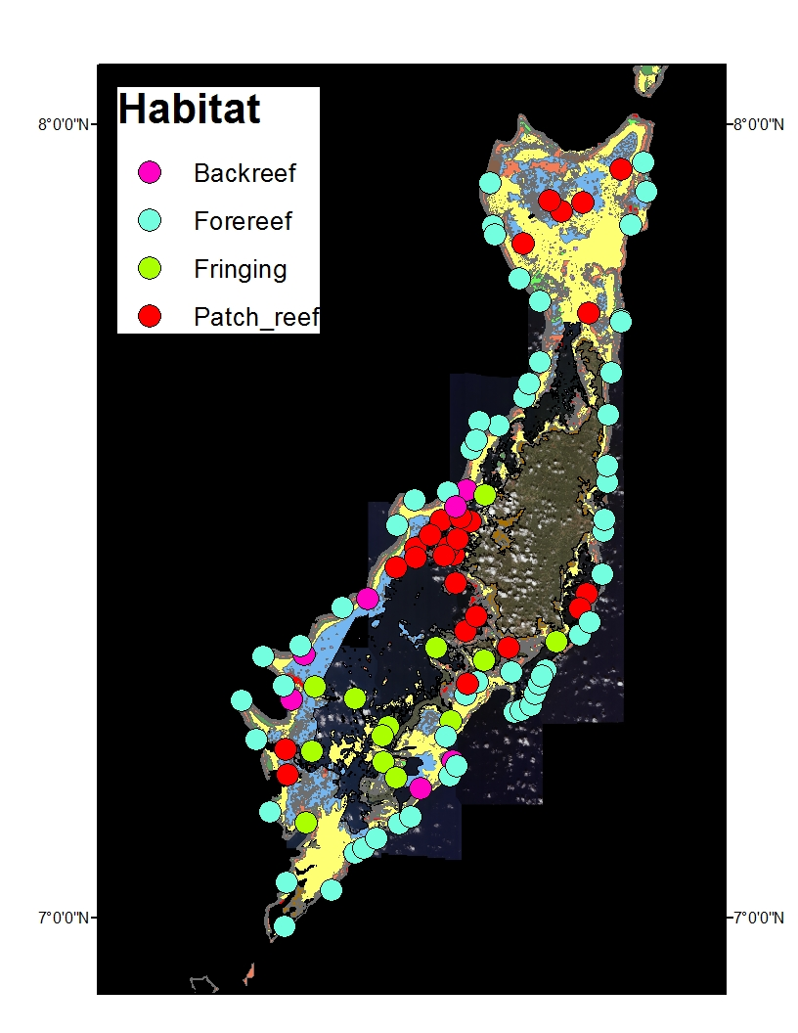

**Figure 2. Sampling locations by habitat type around Palau.**

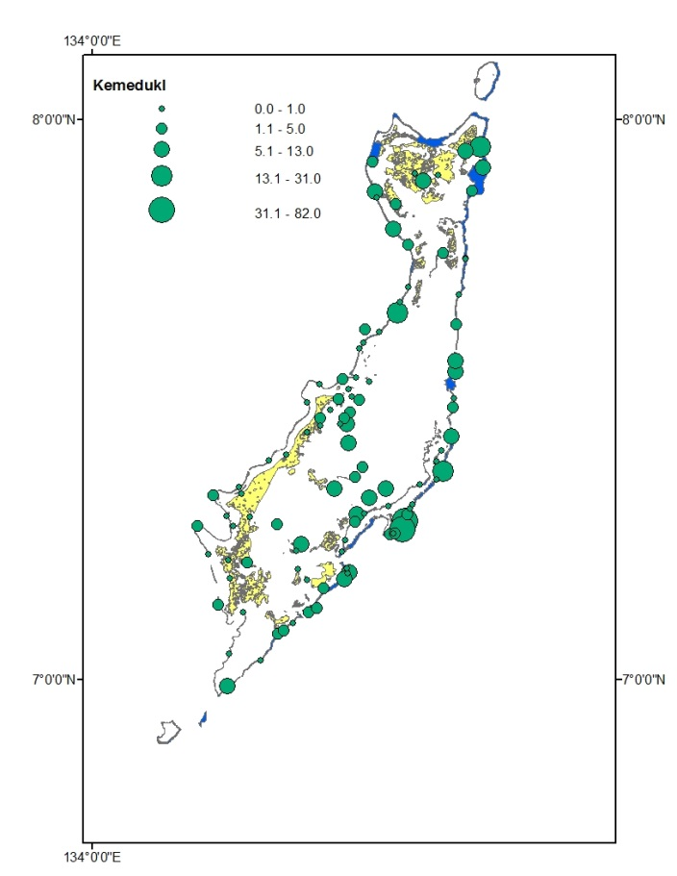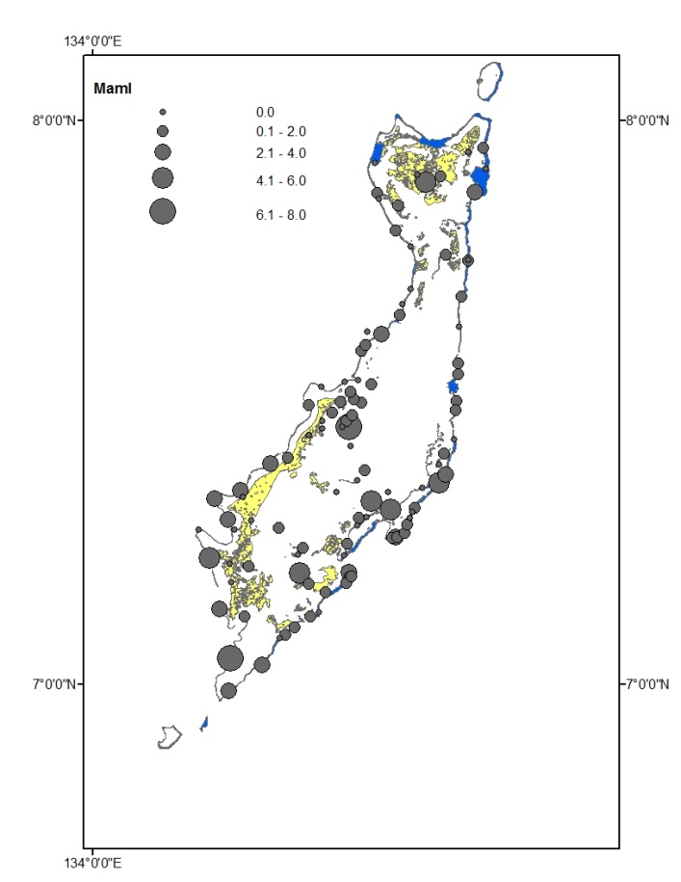

**Figure 3. Numbers of kemedukl and maml around Palau.**

**Table 5. Average number (standard deviation – SD) of *kemedukl* and *maml* per survey by habitat type.**

|  |  |  |  |  |
| --- | --- | --- | --- | --- |
|  | ***kemedukl*** | | ***Maml*** | |
| **Habitat** | **Avg** | **SD** | **Avg** | **SD** |
| **Backreef** | **0.57** | **1.13** | **1.00** | **1.15** |
| **Forereef** | **6.25** | **14.30** | **1.63** | **1.81** |
| **Fringing** | **2.15** | **2.76** | **1.46** | **1.71** |
| **Patch reef** | **2.96** | **3.22** | **1.19** | **1.77** |

**Table 6. Number of *kemedukl* and *maml* by habitat type.**

|  |  |  |  |  |  |  |  |  |  |  |
| --- | --- | --- | --- | --- | --- | --- | --- | --- | --- | --- |
|  | Kemedukl | | | | | Maml | | | | |
| Size cm | Back reef | Fore-reef | Fringing | Patch reef | Total | Back reef | Fore-reef | Fringing | Patch reef | Total |
| 0 |  |  |  |  |  |  |  |  |  |  |
| 20 |  |  | 2 | 1 | 3 |  | 1 |  |  | 1 |
| 30 | 1 |  | 1 | 5 | 7 | 3 | 19 | 11 | 7 | 40 |
| 40 |  | 4 | 3 | 15 | 22 | 1 | 26 | 5 | 9 | 41 |
| 50 |  | 5 | 7 | 18 | 30 | 1 | 19 |  | 8 | 28 |
| 60 |  | 18 | 10 | 16 | 44 |  | 10 | 1 | 3 | 14 |
| 70 |  | 27 | 2 | 4 | 33 | 1 | 8 | 1 | 1 | 11 |
| 80 | 2 | 62 | 1 | 4 | 69 | 1 | 2 |  |  | 3 |
| 90 | 1 | 116 |  | 7 | 124 |  | 5 |  | 2 | 7 |
| 100 |  | 63 | 1 | 7 | 71 |  | 2 | 1 | 1 | 4 |
| 110 |  | 68 |  |  | 68 |  | 3 |  |  | 3 |
| 120 |  | 6 | 1 |  | 7 |  | 1 |  |  | 1 |
| Total | 4 | 369 | 28 | 77 | 478 | 7 | 96 | 19 | 31 | 153 |

**Size frequency** – The mean size of Kemedukl (*Bolbometopon muricatum*) was 80.9 cm (± 31.0) with the maximum size being 125 cm and the smallest being 14 cm. Maml (*Cheilinus undulates* ) averaged 46.8 cm (± 21.3) with a maximum of 120 cm and a minimum of 15 cm.

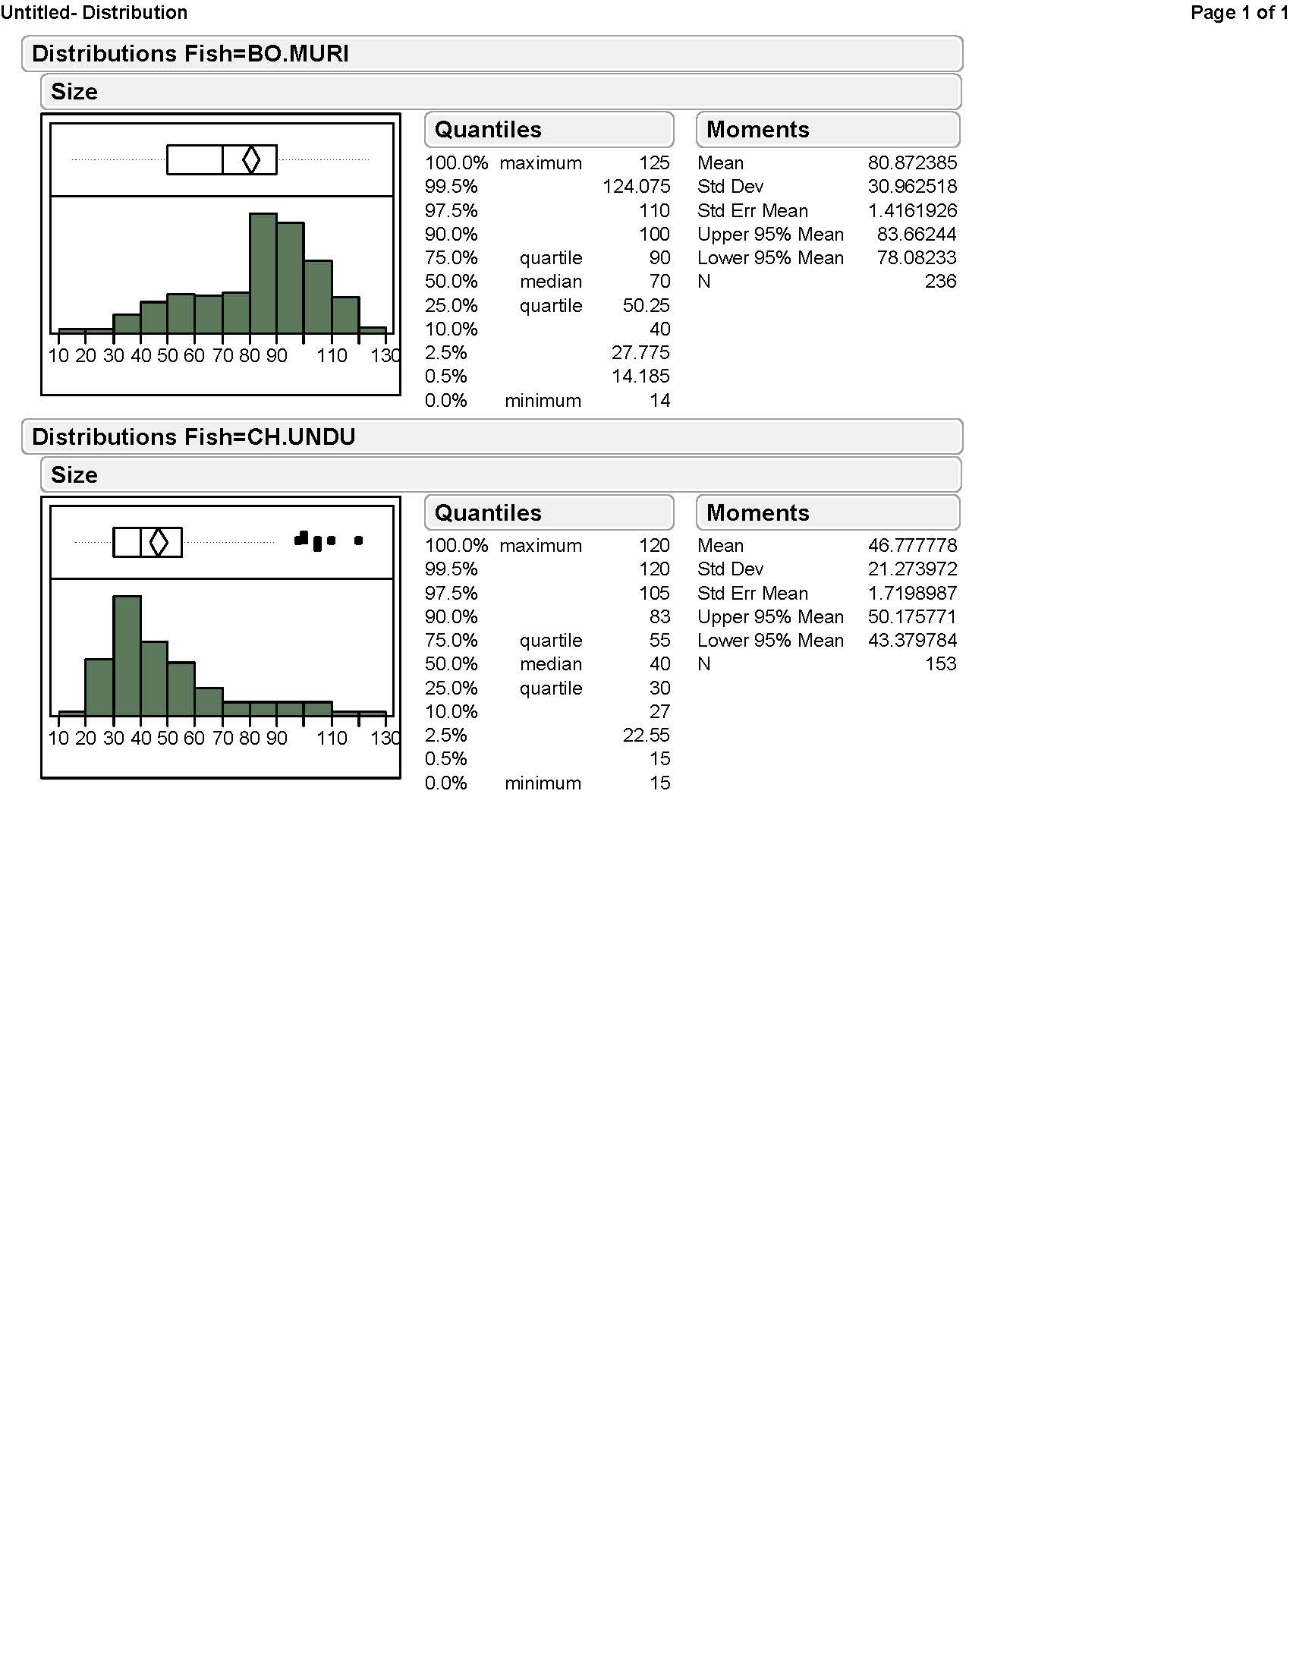

Figure 7. Size frequency distributions for kemedukl (*Bolbometopon muricatum* – BO.MURI) and maml (*Cheilinus undulates* – CH.UNDU).

**Stock assessment:** Data will be analyzed to provide density and biomass of the two target fish for the main habitats around Palau. A stock assessment approach composed of a population model and a method for estimating stock density will be developed based on underwater visual surveys (Sadovy et al. 2007). This approach will include the ability to account for uncertainty in most of the parameters of the model, and we will compute potential sustainable catch (and its associated uncertainty) corresponding to a various levels of fishing mortality. Sustainable fishing mortality rates for the species will be estimated based on commonly used biological reference points (e.g. FMSY; F20%).

**Market data** – Market data for *kemedukl* and *maml* were provided by Palau Department of Marine Resources. Preliminary examination of these data show high landings for kemedukl (40,000 lbs in 1995) until the late 1990s, after which time catch dropped sharply. Landings for maml were at low levels until the late 1990s, when they increased sharply and then declined very rapidly within a few years. Without fishing effort data it is difficult to determine if catch rates declined over the same time period but interviews with fishers should help to shed light on this issue.

 

Figure **8. Market data of *kemedukl* and *maml* in Palau from 1990 to 2006.**

**Cultural value and market survey**: We developed a draft survey (Appendix I) to determine the cultural and market value of *kemedukl* and *maml* to citizens of Palau. We are working with PICRC and TNC to refine this questionnaire before implementation begins.

**Diver willingness to pay survey**: We are developing a diver willingness to pay survey in consultation with experts in the field at the University of Hawaii (Dr. John Lynhan - Department of Economics, Dr. Kirsten Olsen – Department of Natural Resources and Environmental Management, Dr. Brian Schuster – Department of Geography). We have already developed a draft questionnaire and we are working with the human dimension staff at PICRC to implement this survey over the next several months.

**Benefit-Cost Analysis Study:** From the data collected from cultural value and market survey and diver willingness-to-pay survey, we plan to develop a benefit-cost analysis model where two often contradicting resource uses (sustainable fishery operation and marine recreational operation) will be compared in monetary and sociological values to find the middle ground for both operations. This type of study is often used to help decision maker who considers the benefits and costs of alternative recreation activities and programs, then chooses the most beneficial one possible at the lowest possible cost and maximize benefits (Loomis and Walsh 1997).

References

Loomis, J. B., & Walsh, R. G. (1997). *Recreation economic decisions: Comparing benefits and cost.* State College, PA: Venture

Sadovy, Y., Punt, A. E., Cheung, W., Vasconcellos, M., Suharti, S., & Mapstone, B. D. (2007). *Stock assessment approach for the Napoleon fish, Cheilinus undulatus, in Indonesia. A tool for quota-setting for poor-data fisheries under CITES Appendix II Non-Detriment Finding requirements*. FAO

Appendix I

Potential questionnaire for Palau residents about *Maml* and *Kemedukl*

1. Gender, age, state
2. Do you fish?
   1. Full time
   2. Part time
   3. Rarely
   4. None
3. Do you know about the 2006 ban on the take of Maml and Kemedukl?
   1. If yes – do you think this was a good idea and why?
   2. If no – do you think this was a good idea and why?
4. What do you think about the current status of populations of Maml and Kemedukl? On a scale of 1 to 5 with 1 being severely overfished and 5 being healthy
5. Are stocks of Maml and Kemedukl:
   1. Increasing
   2. Declining
   3. Staying the same
6. Do you know about the proposal to lift the ban on take of Maml and Kemedukl?
   1. If yes – do you think this is a good and why?
   2. If yes – do you think this is a bad idea and why?
7. If the ban is lifted would you rather see:
   1. Cultural and subsistence take only
   2. Commercial sale only (markets, restaurants, or both)
   3. Both cultural and commercial
8. If you caught a Maml or Kemedukl, what would you do with it:
   1. Keep for self
   2. Give to relative
   3. Sell to market
   4. Sell to restaurant
9. What restrictions, if any, should be placed on Maml and Kemedukl if the fishery is reopened
   1. No restrictions
   2. No commercial sale
   3. No nighttime fishing on these species
   4. No fishing at spawning aggregations
   5. No fishing during spawning times of the moon
10. Value – on a scale of 1-5 with 1 being not very valuable and 5 being of high value, how would you rate Maml and Kemedukl:
    1. Cultural value
    2. Commercial value